**AN ELECTRONIC DOCUMENT MANAGEMENT SYSTEM FOR LEGAL FIRMS**

**BY**

**BOLUWATIFE ADESINA**

**16/0544.**

**A FINAL YEAR PROJECT**

**SUBMITTED TO THE DEPARTMENT OF COMPUTER SCIENCE AND ENGINEERING DEPARTMENT ,BABCOCK UNIVERSITY, ILISHAN-REMO, OGUN STATE,NIGERIA.**

**FOR THE AWARD OF BACHELOR’S DEGREE IN COMPUTER SCIENCE**

**SUPERVISED BY:**

**DR AJAYI**

**MARCH, 2019**

**CERTIFICATION**

This is to certify that the project entitled”An Electronic Document Management System for Legal Firms” was carried out by BOLUWATIFE ADESINA of the department of Computer Science, Babcock University, Ilishan-Remo, Ogun State.

_______________ _______________

DR AJAYI DATE

SUPERVISOR

**TABLE OF CONTENT**

**CHAPTER ONE- INTRODUCTION TO THE RESEARCH**

* 1. BACKGROUND OF STUDY 1
  2. PROBLEM STATEMENT 1
  3. AIMS & OBJECTIVES 2
  4. SCOPE 2
  5. METHODOLOGY 2

1.6 REQUIREMENTS AND CONSTRAINTS 3

**CHAPTER 2: LITERATURE REVIEW**

2.1 BACKGROUND TO TOPIC 5

2.2 REVIEW OF RELATED WORKS 10

**CHAPTER 3: SYSTEM ANALYSIS AND DESIGN**

3.0 INTRODUCTION 14

3.1 SYSTEM ANALYSIS 14

3.2 DESIGN MODEL USED (SYSTEM DEVELOPMENT LIFE CYCLE) 15

3.2.1 RESEARCH METHODS 16

3.3 ANALYSIS OF EXISTING SYSTEM 17

3.4 ANALYSIS OF PROPOSED SYSTEM 17

3.5 DESIGN AND DEVELOPMENT TOOLS 18

3.5.1 HYPERTEXT MARKUP LANGUAGE (HTML) 19

* + 1. CASCADING STYLE SHEET (CSS) 19

3.5.4 Laravel 19

3.5.5 MY SQL 20

3.6 Requirement Specification 20

3.6.1 System requirements 21

3.6.2 Functional Requirements 21

3.6.3 Non- functional Requirements 21

3.6.4 User Requirements 22

3.6.5 Input/output Requirements 22

3.7 Entity Relationship Diagram of the proposed system 22

3.8 Design of the proposed system 22

3.9 SYSTEM SPECIFICATION 23

3.9.1 HARDWARE SPECIFICATION 24

3.9.2 SOFTWARE SPECIFICATION 24

3.9.3 MOBILE DEVICE SPECIFICATION 25

**CHAPTER FOUR: SYSTEM IMPLEMENTATION, TESTING AND DISCUSSION**

4.0 Introduction 26

4.1 Component and System Testing 26

4.1.1 Database Testing 26

4.1.2 Interface testing 29

**CHAPTER FIVE: SUMMARY RECOMMENDATION AND CONCLUSION.**

5.1. INTRODUCTION 38

5.2. SUMMARY. 38

5.3. RECOMMENDATIONS. 38

5.4. CONCLUSIONS 39

Reference 40

**CHAPTER ONE- INTRODUCTION TO THE RESEARCH**

* 1. **BACKGROUND OF STUDY**

Today more than ever, it is apparent that Nigeria is in the midst of a crucial stage in her development from a third world country to a modern, first world country. Any country with such lofty aspirations must have, among other things, a properly functioning legal system. Alas in Nigeria, that is not the case. Access to a fair trial has become a price too high for majority of the country to pay. The courts of law have become the playgrounds of the rich and mighty and the common man is forgotten as bribery has become the order of the day. To help fix this major, foundational issue at the root of one of our most hallowed institutions, a rethink of some processes are needed. This Electronic Document Management System seeks to be an answer to a few of the problems plaguing this country’s legal system.

* 1. PROBLEM STATEMENT

Since the origins of Nigeria’s judiciary system, nearly everything has been done by hand, from the initial filing of introductory motions and documents to the presentation of exhibits and filling of forms. This has created room for a thriving ecosystem of corruption to develop. Motions are filed but never reach a judge; subpoenas are issued but are never served, Judges take leaves of absence on crucial court dates thereby postponing justice for those who may need it immediately, the problems continue to arise. A need for a new solution is required. A solution that is transparent, modern and will drastically reduce the corruption in the present system. The Electronic Document Management system will address these issues.

* 1. AIMS & OBJECTIVES

The aim of this project is to implement a system to manage legal information. There are certain objectives to be met when designing a system like this.

The objectives of this system include:

* Design of a web application that accepts and stores legal documents and can track their movement.
* Design and implementation of a web page that will be used to navigate the system.
  1. SCOPE

The scope of this project will be limited to the following:

* User Management: Creation and management of user profiles based on roles to allow for an added layer of security in the system as unauthorized users will not be able to see pertinent information. Also there are levels of users within the system. So the information available to a judge will not be available to a defendant.
* Case Management:

Case origination, as well as document upload and management will take place here. Versioning of documents to track editing will also be a feature of this system. Case Monitoring to give a progress report of a case is important as well.

* 1. METHODOLOGY

In the development of the Electronic Document Management System, research and analysis on previous works similar to the proposed systems will be carried out to garner information useful and relevant to the development of the project. The model that is used in this project is the incremental build model. This model combines elements of the waterfall model and the prototyping model. (Gharai,2017). This model involves decomposing the project into a number of components which are designed and built separately. The project is considered complete when it satisfies all the requirements outlined at the beginning of the project.

In the implementation of the system, the following tools and methods would be used:

1. The front end of the system will be built and developed using HTML, JavaScript and CSS as the languages. The IDE used is NetBeans.
2. The back-end of the system will be built using Java. NetBeans will be the IDE used as well
3. The database will be created with MYSQL as the language and Navicat as the database management software.

1.6 REQUIREMENTS AND CONSTRAINTS

16.1 Functional Requirements:

Authentication

* Login: Users of the system can login to the system with a username and password.
* Logout: Users can logout of the system.
* Login failure: If user details are not correct or a database error occurs there should be an error message.

Authorization

* During the login process, the user login roles will be retrieved from the database to determine the level of access to certain documents he can have.

Data Management

* View: Users can view the information on the database that they have access to. This access id determined by the roles outlined in the system. Lawyers can view information pertinent to only cases they are involved in, the System Administrator has access to all documents.
* Document and File Upload: As all files are stored on a cloud server, document and form upload is a crucial part of the Electronic Document Management System. As such files need to be uploaded from local storage to the cloud. The System will be able to accomplish this by use of a dedicated API.

1.6.2 Non-Functional Requirements

Hardware Requirements

This Electronic Document Management System should be able to work on a computer with the following minimum hardware specifications

OS: Windows Vista/8/10 and Linux

CPU: Intel Pentium and above

Capacity :4GB of Hard Disk space

Others include: Mouse, NIC, Keyboard, Monitor

**CHAPTER 2**

LITERATURE REVIEW

2.1 **BACKGROUND TO TOPIC**

The efficiency of service delivery sets the benchmark for public service excellence. A reliable and accurate case file management system is crucial to the effectiveness of day-to-day court operations and fairness of judicial decisions. The International Records Management Trust (IRMT) research (ITRM, 2004) proved that for a system to work with authority, trustworthy and reliability, it needs a strong legal framework of its own.

The increasing nature and advancement of information and communication technology (ICT) due to technological innovations unfolds a new opportunity to significantly improve justice delivery, thereby proffering solutions to the nagging issue of delay in justice delivery in the Nigerian courts which is associated with the conventional method. Undoubtedly, the use of ICT will enhance accessibility, accountability and transparency, with the resultant effect of helping the judiciary to provide adequate and quality services. (Covenant university, 2014)

**2.1.1 The Present Judiciary System and Issues Associated with It**

There is a pressing need for a clear definition of legal framework (Johare 2007). The same is true for the Nigerian Judiciary system and I will attempt to outline the framework of Justice Delivery in Nigeria’s courts system. It is pertinent to state that the judicial proceedings start long before a case reaches the courtroom. The administrative personnel of the courts file and keep registers and documents in compliance with codes of procedure, laws and regulations. For example, a civil action is commenced when a plaintiff (or a plaintiff's lawyer) files a writ of summons or a plaint with the clerk of court in any manner prescribed by law, while a criminal cause is commenced by preferring a charge or filing information, as the case may be. Series of actions are linked to such procedures, such as the collection and formal control of the filed documents by the clerk, the documentation at the time of collection, the registration on a court register of the event and the issuance of a receipt. All these actions require time and resources. By conventional method, a litigant may wish to apply for a copy of court proceedings, rulings or judgment; the usual method is to apply to the court through the court’s Registrar. Notwithstanding the purpose for which such document is needed, the applicant will have to wait for such to be prepared (typed, proofread and re-typed) having paid the necessary fees. This unfortunate scenario and unwarranted delay has been the order of the day since time immemorial.

There are numerous problems associated with the present method of justice delivery in Nigeria. They include:

* **Difficulty of Filing Court Processes**: It is not a gain saying that court’s officials in some courts have made it a tradition not to allow filing of court processes beyond 2.pm. Court’s Officials have made a habit of disallowing litigants access to the registry to file processes once it is 2pm, a convention not provided for in the rules of Court. The implication is that filing of processes becomes impossible even where the litigants come from a far distance, thereby frustrating many cases.
* **Inadequate Working Tools**: Judicial Officers still write in longhand. They have not kept pace with developed countries of the world which make use of electronic equipment to record court proceedings. Since writing in long hands is slow and tedious, it in turn slows down the administration of justice.
* **Inadequate Manpower**: As a result of cumbersome methods in conducting activities in the Nigerian courts, the number of judicial officers to man the court does not match the large numbers of cases before them. The problem here in the actual sense is not the problem of manpower, but the system adopted, hence, the need for towing the electronic path.
* **Insecurity of Court Documents**: Most court documents are kept manually and as a result, they are not well secured. A fire incident can destroy all the documents and there would not be any back up for such. It is also easier for anybody (Court’s Staff inclusive) to tamper with some vital documents and such can be fatal to the smooth administration of justice. Although, some judges now adopt the system of having a complementary file wherein extra court processes are being kept in the event of loss of the original file, such additional files are not safe because they are still kept manually in the same court premises. In addition, there are cases of loss of old case files which makes retrieval of judgments or proceedings difficult after some years.

**2.1.2 Benefits of Using an e-Filing System in Nigerian Courts**

* **Transparency:** Adopting electronic system will foster transparency in the justice delivery, first by making the decided cases available and accessible to the public. This allows lawyers and court users to better understand case laws and increases legal predictability. It also helps in putting judges on their toes and more accountable because anyone can comment on and assess the quality of their decisions. In the United States of America, case information including docket sheets and filed documents, are provided online for viewing and downloading by attorneys and the public at any time from locations other than the court house . Although, something similar is in operation in Nigeria, as there exist some private ICT companies (e.g. Law pavilion and Legalpedia) whose primary business is to make judgments delivered by superior courts available online immediately upon delivery. In addition, it is not an overstatement to say that corruption has crept into every facet of the Nigerian system and the Nigerian judiciary is not an exception. Some businesses, if not all, are becoming increasingly difficult to transact in court without first having to give court officers some money; electronic system will help in reducing corruption where the conventional method is streamlined and lawyers and parties are less required to file documents in person, there will be less influx or traffic in the court’s registry, thereby reducing opportunity for bribery. Of no less importance is the fact that the issue of sharp practices earlier discussed will be reduced if not totally eradicated.
* **Security of Court Documents:** The adoption of electronic method will enhance adequate security of court documents, i.e. processes, record of court proceedings, rulings, judgments and other vital documents. Risks such as loss of documents, cases of missing files and archives destruction can be significantly reduced or eliminated12. The use of electronic archives will improve archives security and confidentiality. This is because there will be a central database for the storage of the documents and only authorized persons can access them.
* **Easier and Faster Access to Information:** Adopting electronic path will aid easier and faster access to information. Because of the nature of the electronic method, information can be accessed 24/7 without necessarily visiting the court in person. With the nature of electronic method, one can access any information from anywhere and anytime. Electronic retrieval of archives will be easier. Litigants and counsels will be able to apply for court’s judgments, rulings and court proceedings notwithstanding the long age of the case.
* Cost Savings: Electronic method guarantees cost reduction in terms of money spent, time and energy used, etc. For instance, transportation costs will reduce drastically; it will enhance minimum use of paper from the moment a case is filed until its disposal; lesser time will be used in conducting activities in court because most works are done online. Lawyers will no longer have to dissipate energy in going to courts and as well as exchanging processes manually.
* Space Savings: Embracing the electronic path will enhance space saving, by eliminating expensive and expansive storage spaces. All documents and archives will be electronically stored and the government will not have to build magnificent storage facilities for court’s archives. Even by comparison, 150 gigabytes hardware has storage capacity equivalent to 70 filing cabinets

**2.1.3 Constraints of Using the Electronic System in Nigeria**

* **Epileptic Electricity Power Supply**: It is not news that the electricity power supply in Nigeria is an apology. This has affected almost all facets of Nigerian economy, the courts inclusive. It is worthy to note that most sectors in Nigeria depend on electricity to conduct their businesses and the poor state of electricity has led to untold reduction in the outputs of these sectors. The epileptic nature of power supply in Nigeria will affect the success of the adoption of electronic method in Nigerian courts, since most ICT infrastructures depend on electricity to function.
* **Lack of IT Skills**: It is not a gain saying that most judges, lawyers, courts staff, staff of law offices and so on lack IT skills; this is as a result of the fact that most of them did not have the opportunity to be trained in ICT while in their various tertiary institutions. The lackadaisical attitude of some lawyers, Judges and court’s officers in ICT has not helped matters, as some of them have willingly refused to acquire necessary ICT skills. All these are threats to a full realization of the electronic system
* **Inadequate Relevant Legal & Regulatory Framework:** Therelevant laws and rules of court in Nigeria are not fashioned in a way to provide for electronic system. Most of the extant laws were made several years back and they do not envisage ICT innovations. Most of the various rules of the courts which are 11 meant to regulate proceedings in courts are not better either. However, quite recently, the Section 84 of the Amended Evidence Act, 2011 has now recognized computer generated documents. Unfortunately, by the same said Act the requirement for the admissibility of such documents is quite cumbersome, and this in way still makes for a set a back on the issue of electronic evidence.

**2.2 REVIEW OF RELATED WORKS**

2.2.1 **Investigation and Development of an e-Judiciary Service for a Citizen-Oriented Judiciary System for Rural Communities (Mfundo Shakes Scott, 2010)**

This article deals with the development of an e-judiciary service for the rural community of Dwesa in South Africa. It reviews the existing legal and ICT systems available in Dwesa as their interconnection is crucial to the proper functioning of the system. The solution also reviews feedback on the completed system from the citizens living in Dwesa. The system was developed using HTML and PHP. The system tried to address the issues presented by Dwesa not having a formal legal system in place due to being neglected by the government. The system put in place handles legal cases and assigns case numbers to them and assigns court dates. However, an issue with the system or a potential gap discovered was the lack of a non-local means of storage of files and information, such as a cloud server. This could pose an issue in case of the loss of the local storage being used due to fire. Versioning of files is also not covered in the system and as such retrieving older editions of documents could prove difficult.

The architecture of the system is outlined in the image below:`

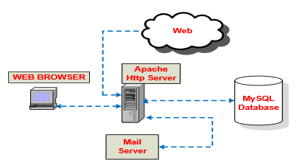

2.2.2 **The Implementation of Electronic Records Management System: A Case Study in Malaysian Judiciary (Wan Satirah Wan Mohd Saman,2011)**

This article concerns itself with the analysis of the efficacy of the present e-court and e-filing systems present in the Malaysian judicial system and seeks to use the results of the research to improve the e-Sharia court system in place at the time. The results of the implementation are represented in table 1 below:

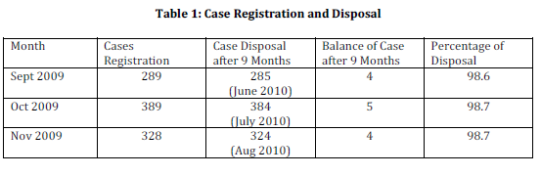

As can be observed from the table above, there has been a high number of cases being closed since the implementation of the e-court system. To apply the benefits of the e-court system to the e-Sharia system, analysis of the issues of the existing system was carried out. The issues identified include: Lack of legal mandate from the Supreme Court of Malaysia, Lack of human resources in the courthouses and software managers to handle the large data and records and Inadequate Documentation and filling of forms online.

Two of the three issues outlined above relate directly to the Nigerian legal system: Lack of human resources and Inadequate documentation. We can look to the solutions implemented by the Malaysian court system for answers. Their solutions include:

* Collaboration with the National Archives of the country so that records management issues can be resolved more easily.
* Implementing a court records management framework that conforms to the legal requirements in line with international standards, developed through a comprehensive research work.

This article shines a light on the successes and issues that the Malaysian government experienced during their implementation of an e-court system and solutions moving forward.

An issue that this article did not address is the lack of a search function that would’ve enabled users to find pending or completed cases by their respective case numbers. The proposed Automated Judiciary System will address the case number assignment issue, implementing case number assignment function.

**CHAPTER 3**

**SYSTEM ANALYSIS AND DESIGN**

**3.0 INTRODUCTION**

This chapter examines the several tools and environments that will be used to design the software. The programming language and database management system (DBMS) in use by the system will also be discussed

The processes involved in designing the system would be discussed as well as the analysis of an existing system by examining characteristics, problems associated with the design of the system.

**3.1 SYSTEM ANALYSIS**

This is the study of previously developed systems as well as the current system in order to help the system developer understand what the system design would entail. Previously developed systems are analysed in order to know the different methodologies and steps taken to develop those systems which would serve as a guide to developing the current system. System analysis basically deals with understanding and analysing thoroughly what the system should do and how the components of the system should be implemented and work together.

The proposed system should enable users to:

* Create and manage case files that hold important legal documents
* Upload and download files and images
* Track case progress
* Accept or decline cases
* Receive payment at the conclusion of cases

**3.2 DESIGN MODEL USED (SYSTEM DEVELOPMENT LIFE CYCLE)**

System development life cycle can be referred to as the various steps or activities taken in order to develop a system. Each level of the System development life cycle uses the result of the previous level.

The System development life cycle consists of 6 distinct phases; the implementation of SDLC is done in order to ensure that no important area is left out upon completion of the system.

* Requirements elicitation and analysis: this phase identifies the business requirements, objectives of the organization, users of the system and analyses what the system is expected to do. This phase produces a requirements specification document.
* Design: based on the details gotten from the requirement specification document, the system is designed and produced.
* Implementation or coding: in this phase, the designed blueprint is turned to reality by writing the source code of the entire application (Olusoga, 2017).
* Testing: the software is tested in order to ensure that the product is really solving the needs identified during the requirements analysis phase (Olusoga, 2017).
* Deployment: in this phase, the software is installed on the systems. When the product is verified and ready to be deployed it is released officially into the suitable market (Olusoga, 2017).
* Support and maintenance; in this phase the system is accessed to ensure it does not become outdated. Plans on how to enhance the system are also made (Olusoga, 2017).

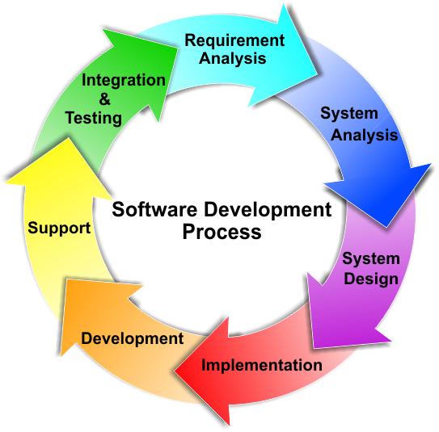

Fig 3.1. Software Development Life cycle (Inductotherm).

**3.2.1 RESEARCH METHODS**

Different software development methodologies exist which have been designed and defined and are ensuing throughout the software development process. These methodologies are also denoted as Software Development Process Models. Every one of them trails a Set of stages exclusive to its type, in order to guarantee success in the progression of software development. The common methodologies include: Waterfall model, prototyping model, iterative model, incremental model, spiral model, rapid application development (RAD) model, extreme programming model and different types of agile methodology.

# 3.1.1 Justification of Model

The Waterfall approach was the first SDLC Model to be used widely in Software Engineering to ensure success of the project. In "The Waterfall" approach, the whole process of software development is divided into separate phases. Every software developed is different and requires a suitable SDLC approach to be followed based on the internal and external factors.

In Waterfall model, typically, the outcome of one phase acts as the input for the next phase sequentially. The sequential phases in waterfall model are: Requirements analysis, System Design, Implementation, Integration and Testing, Deployment and Maintenance. The next phase is started only when the goals of the previous phase have been achieved (sharma, 2016).

3.3.2.1 **Reasons for choosing Waterfall Methodology**

* Requirements are very well documented, clear and fixed
* Product definition is stable
* Technology is understood and is not dynamic
* There are no ambiguous requirements
* Ample resources with required expertise are available to support the product.

3.3.2.2 **Advantages of Waterfall Methodology**

* It is easy to use, simple and understandable.
* It is easy to manage as each phase has specific outputs.
* It has clearly-defined stages.

3.3.2.3 **Disadvantage of Waterfall Methodology**

* It is difficult to make changes.
* It excludes the client and/or end user.
* Testing is delayed until after completion of project

3.3 ANALYSIS OF EXISTING SYSTEM

We would be analysing an existing legal document management system. The name of the System is LawPavilion. It is a case management system that makes it easier for both judges and lawyers to be able to track files and cases in an efficient manner.

3.4 ANALYSIS OF PROPOSED SYSTEM

The proposed system has two levels, or categories of users:

The system administrator: This is the individual in charge of CRUD (Create, Read, Update, and Delete) functions of the system. He can also view all files and documents that are in the system.

The Lawyers: These are the main users of the software. They have the ability to create case files and update the information in them. They can upload and download documents and images.

3.5 DESIGN AND DEVELOPMENT TOOLS

After thorough examination of the necessities and projected features of the system, the suitable programming languages and development tools used in the creation and implementation of this software have been carefully selected. They are examined below:

**3.5.1 HYPERTEXT MARKUP LANGUAGE (HTML)**

HTML which is an acronym for hypertext markup language is the rudimentary construction tool of a webpage. It was invented by sir Tim Berners Lee. It is used to construct and visually denote a webpage. It defines the contents of a webpage but not its functionality and appearance. With the aid of HTML, static as well as dynamic websites can be made. HTML is the language that is used to structure a webpage and its content (MDN web docs, 2019). There are different types of markup languages available but HTML is most used globally. HTML displays text and structures text with the use of various tags and attributes as well.

**3.5.2 CASCADING STYLE SHEET (CSS)**

CSS (Cascading Style Sheet) is a style sheet language used for describing the appearance of a text written in HTML or XML (W3C, 2016). In line with HTML and JavaScript, CSS is a keystone knowledge used generally by most websites to generate visually attractive webpages, user interfaces for web application and user interfaces for many mobile applications.

Three types of CSS exist: inline CSS, internal CSS and external CSS, with the external CSS, the content isn’t partial, each HTML page can be designed nevertheless of the position.

**3.5.4 Laravel**

Laravel is an open-source PHP framework. It was created by Taylor Otwell and intended for the development of web applications following the model-view-controller (MVC) pattern (Conceptualize, 2017). It is a structure that enables one choose and create a program on it. It is used for creating personalized web software in a quick and efficient way.

**3.5.5 MY SQL**

MySQL is an oracle-backed database system used on the web that runs on a server. It is the most common open source relational database SQL database management system (Techtarget).It is best for both small and big applications. It is very fast, reliable and easy to use. The data in MySQL database are stored in tables (MySQL).

* + 1. **Bootstrap**

Bootstrap is a [free and open-source](https://en.wikipedia.org/wiki/Free_and_open-source) front-end [Web framework](https://en.wikipedia.org/wiki/Web_framework). It contains [HTML](https://en.wikipedia.org/wiki/HTML) and [CSS](https://en.wikipedia.org/wiki/CSS)-based design templates for [typography](https://en.wikipedia.org/wiki/Typography), [forms](https://en.wikipedia.org/wiki/Form_(HTML)), buttons, navigation and other interface components, as well as optional JavaScript extensions. Unlike many earlier web frameworks, it concerns itself with [front-end development](https://en.wikipedia.org/wiki/Front-end_web_development) only. Bootstrap is a web framework that focuses on simplifying the development of informative web pages (as opposed to [web apps](https://en.wikipedia.org/wiki/Web_Apps)). The primary purpose of adding it to a web project is to apply Bootstrap's choices of color, size, font and layout to that project. As such, the primary factor is whether the developers in charge find those choices to their liking. Once added to a project, Bootstrap provides basic style definitions for all [HTML elements](https://en.wikipedia.org/wiki/HTML_element). The end result is a uniform appearance for prose, tables and form elements across [web browsers](https://en.wikipedia.org/wiki/Web_browser). In addition, developers can take advantage of CSS classes defined in Bootstrap to further customize the appearance of their contents. For example, Bootstrap has provisioned for light- and dark-colored tables, page headings, more prominent pull quotes, and text with a highlight.

**3.6 Requirement Specification**

Requirement specification is a file that captures a complete picture about how the system is expected to work. It is generally gotten at the end of the requirements engineering/ analysis phase. There are two basic types of requirement specification; they include functional and non-functional requirements.

**3.6.1 System requirements**

Some of the system requirements are:

1. The system needs a PHP enabled server to run
2. The system will have a database to store all the necessary information.
3. The system needs an internet connection to run.

**3.6.2 Functional Requirements**

This is the detailed description of the functionalities of a system, how it will react to a certain input, and how the system should behave in certain conditions. This also includes the parameters that must be present for the system to carry out its function and task adequately.

1. The system should not grant access to users with incorrect login details.
2. The system should allow user to view and edit case files.
3. The system should allow users to receive payments.
4. The system should provide date and status information of case files in the database
5. The system allows the admin view the amount of registered users

**3.6.3 Non- functional Requirements**

Non-functional requirements describe the quality features of the system.

* Usability: the system shall be able to carry out functions without problems.
* Performance: the system response shall be very fast
* Reliability: the system should have a long mean time between failures.
* The system shall give room for upgrade.
* The system shall be supported by all modern browsers.
* The system will validate users.

**3.6.4 User Requirements**

The users of the system would be capable to do the following:

1. Login to have access to website.
2. Open new cases.
3. View and manage their cases.
4. Receive payment.
5. Log out of the system.

3.6.5 Input/output Requirements

The data expected from users as input includes number of items, name, case number, files and images while expected output from the application is the same information returned to the user when it is requested for.

3.7 Entity Relationship Diagram of the proposed system

An entity relationship diagram is a diagram for describing the data or its process requirements in an abstract way that lends itself to ultimately being implemented in a database such as a relational database. It is a specialized graphic that illustrates the relationships between entities in database.

3.8 Design of the proposed system

The system would be used by two users; the administrator and the lawyer

**3.8.1 Use cases**

Administrator: in charge of admin responsibilities.

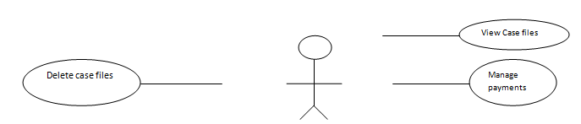

Fig 3.4 Use case model showing the administrator

Lawyer: Lawyer can create and view case files.

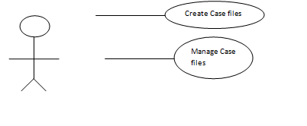

Fig 3.5 Use case model showing the Lawyer

3.9 **SYSTEM SPECIFICATION**

This section describes the necessary requirements needed for this software to operate on with their devices such as:

**3.9.1 HARDWARE SPECIFICATION**

This section of hardware configuration is an important task related to any software development project because it states the physical visibility devices users need to operate on the salon management system.

1. Technical Devices: Laptops, Mobile devices (SMARTPHONE)
2. Processor: Pentium/ Intel core i7 (Any processor is compatible)
3. Processor Speed: 1.4GHZ or higher
4. Hard disk: 80GB or higher
5. Operating system: Windows XP/10 or iOS
6. System Memory: 128MB Minimum or 256MB Recommended
7. Cache size: 512kb
8. RAM: 512MB Minimum or higher
9. Network Card: Any network card
10. Network Connection: Must be Present either in LAN or Wireless connection.

**3.9.2 SOFTWARE SPECIFICATION**

The required software specifications needed for the proposed system is:

1. An operating system – windows/ ios/Linux
2. A web browser such as Mozilla Firefox, Opera mini, Google Chrome etc.
3. Wamp server recent version containing the following
   * 1. MySQL
     2. PHP.

**3.9.3 MOBILE DEVICE SPECIFICATION**

1. Phone Type: Must be a Smartphone
2. Operating System: Android from Froyo to current version or IOS
3. Memory space: 4GB OR HIGHER
4. Network Connection: Must be present
5. Web browsers: Opera mini, Google Chrome or any browser that can access websites
6. Mobile Data: 2G/3G/4G
7. Network type: MTN, 9MOBILE, AIRTEL, GLO etc.

**CHAPTER FOUR**

SYSTEM IMPLEMENTATION, TESTING AND DISCUSSION

4.0 Introduction

This chapter centers on the implementation or the application of the efficient system and the test for plausible defects and properties such as performance and dependability. These tests comprise the execution of the system with test statistics to ensure that all necessities have been appropriately encountered in order to guarantee a high quality and user responsive system. The various tests to be carried out would be expatiated further in the subsequent segments.

4.1 Component and System Testing

This involves testing the basic units of the system. The various components that make up the system are tested to ensure that the system is completely free from errors and working the way it ought to work. System testing involves testing of an integrated system to confirm that it meets its specified requirements (Software Testing Fundamentals, 2019).

**4.1.1 Database Testing**

A database is an assemblage of information that is prearranged so that it can be simply retrieved, managed and updated. Each table in the database holds fields closely related which are directed by a set of rules and constrictions thereby limiting the type of data stored in them. The Database Management System (DMBS) evades misapplication by guaranteeing that these checks aren’t violated.

It is important to maintain data in a stable and permanent form. Information stored in cookies, sessions, browser cache and other temporary repository aren’t stable as they cannot be counted upon to be always there, and therefore it is important to secure a reliable storage medium. This reliable medium is the relational database management system queried with MySQL.

The Legal Document Management System database consists of 5 tables and each table comprises the name of the fields, data types and other restraints that identify the table. Below are brief descriptions of each table along with screenshots.

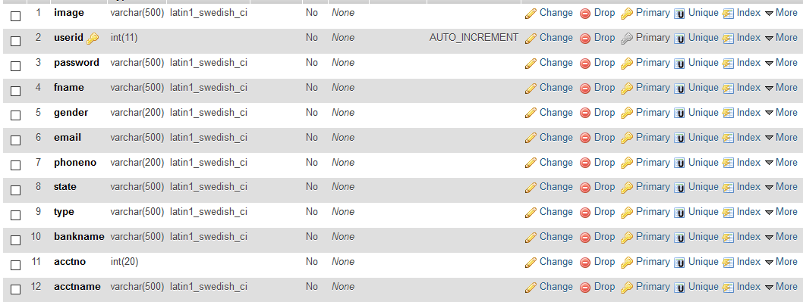

Fig 4.1: Users table.

The users table is where the information of all the users are recorded and stored.

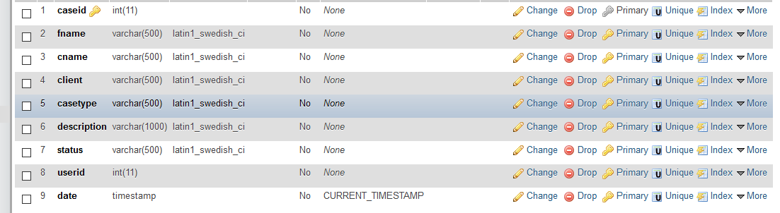

Fig 4.2 Admin table

The admin table contains information about the administrator of the system.

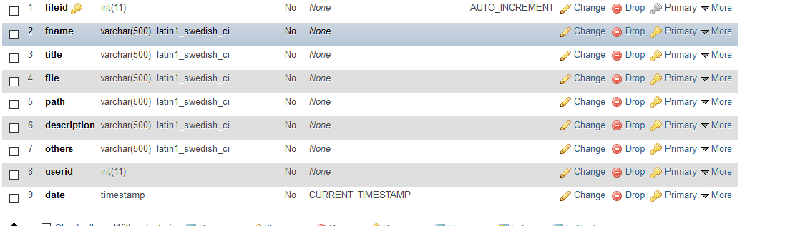

Fig 4.3 Documents table

The Documents table contains information about every document in the system

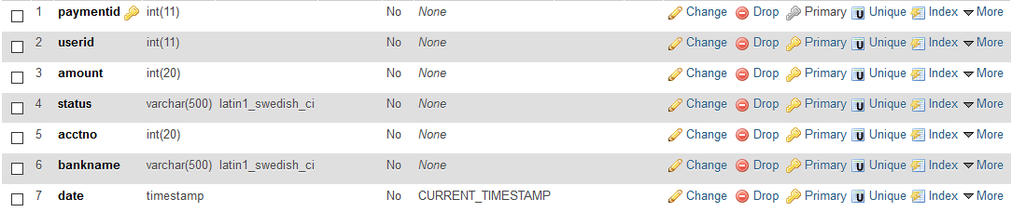

Fig 4.4 Paymentinfo table

This table contains information pertinent to payments made to the lawyers



Fig 4.5 usercase table

This table

**4.1.2 Interface testing**

Interface testing is the process of testing the graphical user interface of the system to confirm it meets its written specifications, interface testing is also done to check whether the individual modules are communicating properly.

‘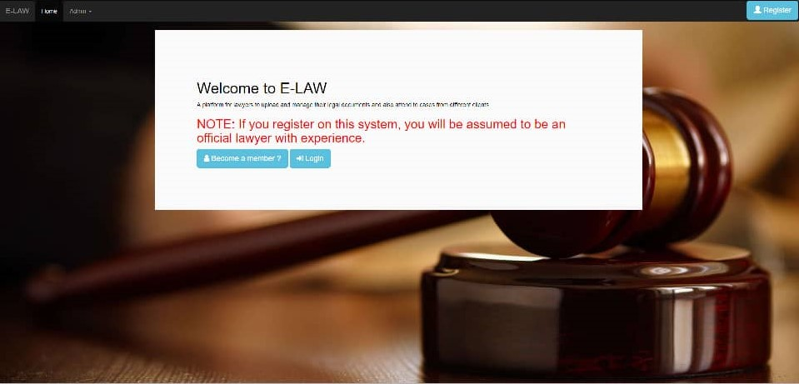

Fig 4.7: Login Page.

After the user has registered successfully, the system directs the user to login

4.1.3 SYSTEM TESTING

System testing involves integrating the components of the system features and then testing this integrated system. System testing focuses on the behaviour of the system as a whole. The tests are derived from requirement specifications (pezze, 2012).There are two major phases of system testing, they are;

1. Integration testing
2. Release testing

**4.1.3.1 Integration Testing**

This involves the building of a system from its various components and analysing the resultant system for problems that arise from the components communication.

Integration testing is mostly concerned with finding defects in the entire system. Integration testing focuses on communication and interface problems that may arise during the integration of modules (pezze, 2012).

System integration involves identifying groups of components that provide some system functionality and integrating them by adding code that makes them work together.

**4.1.3.1 Release Testing**

This involves testing a description of the system before it is out to users to ensure that it works as it ought to work.

**4.2 USER GUIDE**

The user guide is to help the users of the system understand how they can use the system. All users are expected to have a good knowledge of how to operate a computer. The following procedures can be followed in operating this system.

1. Type in the web address to access the Legal Management System.
2. The website loads and the register/ login page is displayed.
3. User registers or logs in if they already registered.
4. User uploads or downloads case information
5. User manages folders

**4.3 RISK IDENTIFICATION, CATEGORY, COMPONENT and MITIGATION**

A risk is the likelihood that an unwanted incident could ensue. Software risks may be categorised as follows:

1. Uncertainty: that means there is a probability that the risk would not occur and there is also a probability that it would (Olusoga, 2017).
2. Loss - if the risk becomes a reality, unwanted consequences or losses will occur (Olusoga, 2017).

**4.3.1 Risk Categories**

Risks fall under the following categories:

1. **Project Risk**: These are the types of risk that threaten the plan of the project. They help identify potential hitches and their effects on a software project (Olusoga, 2017).
2. **Technical Risk**: These risks threaten the value and aptness of the software to be produced (Olusoga, 2017).
3. **Business Risk**: These risks threaten the feasibility of the system to be made. Some categories of risks include market risk, sales risk, strategy risk and management risk (Olusoga, 2017).

**RISK COMPONENTS**

Risk components can be grouped into four:

- **Performance Risk**: this refers to the degree of uncertainty that the product to be produced would meet its requests and be suitable for its planned use (Olusoga, 2017).

- **Cost Risk**: this refers to the degree of uncertainty that the budget allotted for the project will be maintained (Olusoga, 2017).

- **Support Risk**: this refers to the degree of uncertainty that the software to be built will be easy to correct, adapt, support, and enhanced (Olusoga, 2017).

-**Schedule Risk**: this refers to the amount of uncertainty that the project plan will be sustained and that the product will be delivered on time (Olusoga, 2017).

**Risk Impact**

This refers to the extent of the damage the risk identified can do to the project. The may be caused by the occurrence of different risks. They can be classified into

* Negligible (1)
* Marginal(2)
* Critical(3)
* Catastrophic (4 (Olusoga, 2017)).

**4.3.2 Risk Mitigation, Monitoring & Management (RMMM)**

This refers to the measures taken to correct the risk. A good RMMM should avoid the risk, monitor and also manage it.

|  |  |  |  |  |  |
| --- | --- | --- | --- | --- | --- |
| Risk | Risk Component | Impact | Risk Category | Probability | RMMM |
| Requirements might change during the building process. | Schedule risk | Marginal | Project risk | 80% | More time would be devoted in gathering all the possible requirements and perfect understanding of the project before development |
| The members of the group are not familiar with the technology to be used for the project | Schedule risk | Marginal | Technical risk | 60% | Project members have to learn how to implement the technology used after class hours |
| The time limit for project submission is restricted. | Performance risk | Critical | Business risk | 40% | More attention would be put towards building the application before deadline. |
| End-users might reject the new system | Performance risk  Support risk  Schedule risk | Critical | Business risk | 20% |  |

**Table 4.1: Risk Mitigation, Monitoring & Management (RMMM)**

System integration involves identifying groups of components that provide some system functionality and integrating them by adding code that makes them work together.

**4.1.3.1 Release Testing**

This involves testing a description of the system before it is out to users to ensure that it works as it ought to work.

**4.2 USER GUIDE**

The user guide is to help the users of the system understand how they can use the system. All users are expected to have a good knowledge of how to operate a computer. The following procedures can be followed in operating this system.

1. Type in the web address to access the Legal Management System.
2. The website loads and the register/ login page is displayed.
3. User registers or logs in if they already registered.
4. User uploads or downloads case information
5. User manages folders

**4.3 RISK IDENTIFICATION, CATEGORY, COMPONENT and MITIGATION**

A risk is the likelihood that an unwanted incident could ensue. Software risks may be categorised as follows:

1. Uncertainty: that means there is a probability that the risk would not occur and there is also a probability that it would (Olusoga, 2017).
2. Loss - if the risk becomes a reality, unwanted consequences or losses will occur (Olusoga, 2017).

**4.3.1 Risk Categories**

Risks fall under the following categories:

1. **Project Risk**: These are the types of risk that threaten the plan of the project. They help identify potential hitches and their effects on a software project (Olusoga, 2017).
2. **Technical Risk**: These risks threaten the value and aptness of the software to be produced (Olusoga, 2017).
3. **Business Risk**: These risks threaten the feasibility of the system to be made. Some categories of risks include market risk, sales risk, strategy risk and management risk (Olusoga, 2017).

**RISK COMPONENTS**

Risk components can be grouped into four:

- **Performance Risk**: this refers to the degree of uncertainty that the product to be produced would meet its requests and be suitable for its planned use (Olusoga, 2017).

- **Cost Risk**: this refers to the degree of uncertainty that the budget allotted for the project will be maintained (Olusoga, 2017).

- **Support Risk**: this refers to the degree of uncertainty that the software to be built will be easy to correct, adapt, support, and enhanced (Olusoga, 2017).

-**Schedule Risk**: this refers to the amount of uncertainty that the project plan will be sustained and that the product will be delivered on time (Olusoga, 2017).

**Risk Impact**

This refers to the extent of the damage the risk identified can do to the project. The may be caused by the occurrence of different risks. They can be classified into

* Negligible (1)
* Marginal(2)
* Critical(3)
* Catastrophic (4 (Olusoga, 2017)).

**4.3.2 Risk Mitigation, Monitoring & Management (RMMM)**

This refers to the measures taken to correct the risk. A good RMMM should avoid the risk, monitor and also manage it.

|  |  |  |  |  |  |
| --- | --- | --- | --- | --- | --- |
| Risk | Risk Component | Impact | Risk Category | Probability | RMMM |
| Requirements might change during the building process. | Schedule risk | Marginal | Project risk | 80% | More time would be devoted in gathering all the possible requirements and perfect understanding of the project before development |
| The members of the group are not familiar with the technology to be used for the project | Schedule risk | Marginal | Technical risk | 60% | Project members have to learn how to implement the technology used after class hours |
| The time limit for project submission is restricted. | Performance risk | Critical | Business risk | 40% | More attention would be put towards building the application before deadline. |
| End-users might reject the new system | Performance risk  Support risk  Schedule risk | Critical | Business risk | 20% |  |

**Table 4.1: Risk Mitigation, Monitoring & Management (RMMM)**

**CHAPTER FIVE**

**SUMMARY RECOMMENDATION AND CONCLUSION.**

**5.1. INTRODUCTION**

This chapter contains the total summary of the entire project and recommends how to improve on certain parts or features of the project in future. It also draws a conclusion to the design and methodology as well as what the project as a whole.

**5.2. SUMMARY.**

The Nigerian legal system is famously chaotic and has numerous issues with credibility and document integrity. Files and pertinent case information in those files are routinely misplaced, either due to negligence or purposeful mismanagement. In a bid to solve some of these issues the e-legal document management system was created. With the implementation of an online legal document storage space, some of these problems have been rectified. If implemented in legal offices around the country, a level of accountability will be established within the legal system.

**5.3. RECOMMENDATIONS.**

Future projects on this topic will seek to add a versioning feature so that the documents can be edited and the changes to the edited documents can be tracked. Larger file sizes will also be accepted.

**5.4. CONCLUSIONS.**

The use of the legal document management system has shown that it works satisfactorily by accepting and displaying documents. It has also proven it can handle multiple users signed in on the network

**REFRENCES**

Yusuf O.A, SAN. (2010). The Nigerian Evidence Act & Electronically –Generated Evidence: A Need to Fast Track The System. Contemporary Issues in the Nigerian legal Landscape. A Compendium in Honour of Prince Lateef Fagbemi, SAN. Pp. 66-99

Vilquin J & Bosio, E; Improving court efficiency: the Republic of Korea’s e-court experience. Retrieved from [http://www.doingbusiness.org/~/media/GIAWB/Doing%20Business/Documents/Annual-Reports/English/DB14-Chapters/DB14- Improving-court-efficiency.pdf](http://www.doingbusiness.org/~/media/GIAWB/Doing%20Business/Documents/Annual-Reports/English/DB14-Chapters/DB14-%20Improving-court-efficiency.pdf)

Fashakin, Y. (2007). Probate and Administration of Estate. In Afolayan A.F. & Okorie, P.C. (Ed.). Modern Civil Procedure Law. (Pp529-562) Dee-Sage Nigeria Ltd, Lagos Nigeria. 9 Olopade, O. (2004, August). Access to Justice- Factors militating Against and Solutions Thereto. A paper presented at the 18th international conference of the international society for the reform of criminal law-keeping justice system just and accountable: A principled approach in challenging times, at Hotel Omni Mont-Royal, Montreal, Quebec, Canada, from 8-12,. <http://www.isrcl.org/papers/2004/2004/Olopade.pdf>

Olusoga. (2017). *Software Engineering*.

pezze, M. Y. (2012). Integration and System Testing.

*Software Testing Fundamentals*. (2019). Retrieved February 17, 2019, from <http://softwaretestingfundamentals.com/system-testing/>

Velicogna, M (June 2007), Justice Systems and ICT: What can be learned from Europe? Retrieved from http://www.utrechtlawreview.org/Volume 3issue 1 Pp. 129

sharma, L. (2016, april 17). *Toolsqa*. Retrieved february 10, 2018, from <https://www.toolsqa.com/software-testing/waterfall-model/>

*Inductotherm*. (n.d.). Retrieved february february, 2019, from <https://igpune.com/software-development-process/>

*W3C*. (2016). Retrieved february 17, 2019, from <https://www.w3.org/standards/webdesign/htmlcss>

*Conceptualize*. (2017, January 27). Retrieved February 17, 2019, from <https://www.conceptualize.ae/blog/php-frameworks-why-did-we-choose-laravel/>

*MDN*. (2019). Retrieved February 17, 2019, from <https://developer.mozilla.org/en-US/docs/Glossary/jQuery>

*MDN web docs*. (2019). Retrieved February 17, 2019, from <https://developer.mozilla.org/en-US/docs/Learn/Getting_started_with_the_web/HTML_basics>

*MySQL*. (n.d.). Retrieved February 17, 2019, from <https://dev.mysql.com/doc/refman/5.7/en/what-is-mysql.html>

*Techtarget*. (n.d.). Retrieved february 17, 2019, from Search\oracle: <https://searchoracle.techtarget.com/definition/MySQL>

*TRY QA*. (n.d.). Retrieved February 17, 2019, from <http://tryqa.com/what-is-waterfall-model-advantages-disadvantages-and-when-to-use-it/>

*WPbeginner*. (n.d.). Retrieved February 17, 2019, from <https://www.wpbeginner.com/glossary/apache/>